

| Title: Demonstrate axios to Create Mock API Server |
| --- |

**AIM:** To Implement the React Axios

**Problem Definition:**

Build a React application that interacts with a RESTful API using Axios to perform CRUD (Create, Read, Update, Delete) operations. The application should allow users to view, add, update, and delete data from the server. The application should allow users to view, add, update, and delete student data, with smooth navigation between different views using the useNavigate hook.

**Requirements:**

* Create a new React application using create-react-app.
* Install Axios using npm install axios.
* Install react-router-dom to handle navigation (npm install react-router-dom).

**Data Fetching:**

Create a component (StudentList.js) that fetches a list of students from a RESTful API endpoint (e.g., https://api.example.com/students) and displays them in a table or list. Handle loading states and errors during the fetch process.

**Adding a New Student:**

* Implement a form component (AddStudent.js) that allows users to add a new student record.
* Use Axios to send a POST request to the API with the new student data.
* Upon successful submission, navigate the user back to the student list view using useNavigate and display the newly added student in the list.

**Updating Student Data:**

* Implement an edit functionality in a separate component (EditStudent.js) that allows users to update an existing student's information.
* Use Axios to send a PUT request to the API with the updated student data.
* Upon successful submission, navigate the user back to the student list view using useNavigate, and reflect the updated student information in the list.

**Deleting a Student:**

* Add a delete button next to each student in the list.
* When the delete button is clicked, use Axios to send a DELETE request to the API.
* Upon successful deletion, the student should be removed from the list without requiring a page reload.

**Navigation:**

* Use useNavigate to smoothly navigate between different components/views (StudentList, AddStudent, EditStudent).
* Ensure that the browser’s back and forward buttons work correctly to navigate between the views.

**Resources used:**

**_____________________________________________________________________**

**Expected OUTCOME of Experiment:**

**CO 2:**. Illustrate the concepts of various front-end, back-end web application development technologies & frameworks using different web development tools.

**___________________________________________________________________**

**Books/ Journals/ Websites referred:**

1. Shelly Powers Learning Node O’ Reilly 2 nd Edition, 2016.

**Pre Lab/ Prior Concepts:**

**Write details about the following content**

* useNavigate  
  useNavigate is a hook provided by react-router-dom, a popular library used for routing in React applications. This hook is used to programmatically navigate between different routes in a React application.useNavigate returns a function that can be used to navigate to different routes programmatically.
* Axios  
  Axios is a promise-based HTTP client for JavaScript used to make HTTP requests from a web browser or Node.js. It is popular for handling asynchronous data fetching, posting, and error handling.Axios simplifies the process of sending HTTP requests and handling responses.It supports various HTTP methods such as GET, POST, PUT, DELETE, etc.
* Routes in React   
  In React applications, routes define the different paths users can navigate to and determine what components should be rendered based on the current URL. Routing in React is typically handled using libraries like react-router-dom.

**Implementation Details:**

**Index.js**

**import { StrictMode } from 'react'**

**import { createRoot } from 'react-dom/client'**

**import {**

**createBrowserRouter,**

**RouterProvider,**

**} from "react-router-dom";**

**//import App from './App.jsx'**

**import './index.css'**

**import StudentList from './components/StudentList.jsx';**

**import EditStudent from './components/EditStudent.jsx';**

**import AddStudent from './components/AddStudent.jsx';**

**import DeleteStudent from './components/DeleteStudent.jsx';**

**const router = createBrowserRouter([**

**{**

**path: "/",**

**element: <StudentList/>,**

**},**

**{**

**path: "/add",**

**element: <AddStudent/>,**

**},**

**{**

**path: "/edit",**

**element: <EditStudent/>,**

**},**

**{**

**path: "/delete",**

**element: <DeleteStudent/>,**

**},**

**]);**

**createRoot(document.getElementById('root')).render(**

**<StrictMode>**

**<RouterProvider router={router} />**

**</StrictMode>,**

**)**

**StudentList.jsx**

**import React, { useEffect, useState } from 'react';**

**import axios from 'axios';**

**import { useNavigate } from 'react-router-dom';**

**const StudentList = () => {**

**const url = "http://localhost:3000/students";**

**const [students, setStudents] = useState([]);**

**const fetchStudents = async () => {**

**try {**

**const response = await axios.get(url);**

**setStudents(response.data);**

**} catch (error) {**

**console.error('Error fetching students:', error);**

**}**

**};**

**const navigate = useNavigate();**

**useEffect(() => {**

**fetchStudents();**

**}, []);**

**return (**

**<div style={{ padding: '20px' }}>**

**<h1>Student List</h1>**

**<table style={{ width: '100%', borderCollapse: 'collapse' }}>**

**<thead>**

**<tr style={{ backgroundColor: '#f4f4f4' }}>**

**<th style={{ border: '1px solid #ddd', padding: '8px' }}>ID</th>**

**<th style={{ border: '1px solid #ddd', padding: '8px' }}>First Name</th>**

**<th style={{ border: '1px solid #ddd', padding: '8px' }}>Last Name</th>**

**<th style={{ border: '1px solid #ddd', padding: '8px' }}>Age</th>**

**</tr>**

**</thead>**

**<tbody>**

**{students.map(student => (**

**<tr key={student.id}>**

**<td style={{ border: '1px solid #ddd', padding: '8px' }}>{student.id}</td>**

**<td style={{ border: '1px solid #ddd', padding: '8px' }}>{student.firstName}</td>**

**<td style={{ border: '1px solid #ddd', padding: '8px' }}>{student.lastName}</td>**

**<td style={{ border: '1px solid #ddd', padding: '8px' }}>{student.age}</td>**

**</tr>**

**))}**

**</tbody>**

**</table>**

**<div style={{ marginTop: '20px' }}>**

**<button**

**onClick={() => navigate('/add')}**

**style={{ padding: '10px 15px', marginRight: '10px', backgroundColor: '#007bff', color: 'white', border: 'none', borderRadius: '5px', cursor: 'pointer' }}**

**>**

**Add Student**

**</button>**

**<button**

**onClick={() => navigate('/edit')}**

**style={{ padding: '10px 15px', marginRight: '10px', backgroundColor: '#28a745', color: 'white', border: 'none', borderRadius: '5px', cursor: 'pointer' }}**

**>**

**Edit Student**

**</button>**

**<button**

**onClick={() => navigate('/delete')}**

**style={{ padding: '10px 15px', backgroundColor: '#dc3545', color: 'white', border: 'none', borderRadius: '5px', cursor: 'pointer' }}**

**>**

**Delete Student**

**</button>**

**</div>**

**</div>**

**);**

**};**

**export default StudentList;**

**AddStudent.jsx**

**import React from 'react'**

**import { useState, useEffect } from 'react';**

**import axios from 'axios';**

**import { useNavigate } from 'react-router-dom';**

**const AddStudent = () => {**

**const [firstName, setFirstName] = useState();**

**const [lastName, setLastName] = useState();**

**const [age, setAge] = useState();**

**const url = "http://localhost:3000/students"**

**const createStudent = ()=> {**

**const student = {**

**firstName,**

**lastName,**

**age: parseInt(age, 10)**

**};**

**axios.post(url, student)**

**}**

**const handleSubmit = (e)=>{**

**e.preventDefault();**

**createStudent()**

**}**

**const navigate = useNavigate();**

**return (**

**<div>**

**<form onSubmit={handleSubmit}>**

**<input type="text"**

**id="firstName"**

**name="firstName"**

**value={firstName}**

**onChange={(e) => setFirstName(e.target.value)}**

**required>**

**</input>**

**<input type="text"**

**id="lastName"**

**name="lastName"**

**value={lastName}**

**onChange={(e) => setLastName(e.target.value)}**

**required>**

**</input>**

**<input**

**type="number"**

**id="age"**

**name="age"**

**value={age}**

**onChange={(e) => setAge(e.target.value)}**

**required>**

**</input>**

**<button>Submit</button>**

**</form>**

**<button onClick={()=>{navigate('/')}}>Go Home</button>**

**</div>**

**)**

**}**

**export default AddStudent**

**EditStudent.jsx**

**import React, { useState, useEffect } from 'react';**

**import axios from 'axios';**

**import { useNavigate } from 'react-router-dom';**

**const EditStudent = () => {**

**const [studentId, setStudentId] = useState('');**

**const [student, setStudent] = useState(null);**

**const [firstName, setFirstName] = useState('');**

**const [lastName, setLastName] = useState('');**

**const [age, setAge] = useState('');**

**const url = `http://localhost:3000/students/${studentId}`;**

**const navigate = useNavigate();**

**useEffect(() => {**

**if (studentId) {**

**axios.get(url)**

**.then(response => {**

**setStudent(response.data);**

**setFirstName(response.data.firstName);**

**setLastName(response.data.lastName);**

**setAge(response.data.age);**

**})**

**.catch(error => console.error('Error fetching student:', error));**

**}**

**}, [studentId]);**

**const handleUpdate = () => {**

**const updatedStudent = {**

**firstName,**

**lastName,**

**age: parseInt(age, 10)**

**};**

**axios.put(url, updatedStudent)**

**.then(response => {**

**console.log('Student updated:', response.data);**

**})**

**.catch(error => console.error('Error updating student:', error));**

**};**

**const handleSubmit = (e) => {**

**e.preventDefault();**

**handleUpdate();**

**};**

**return (**

**<div>**

**<h2>Update Student</h2>**

**<input**

**type="text"**

**placeholder="Enter Student ID"**

**value={studentId}**

**onChange={(e) => setStudentId(e.target.value)}**

**/>**

**{student && (**

**<form onSubmit={handleSubmit}>**

**<input**

**type="text"**

**id="firstName"**

**name="firstName"**

**value={firstName}**

**onChange={(e) => setFirstName(e.target.value)}**

**required**

**/>**

**<input**

**type="text"**

**id="lastName"**

**name="lastName"**

**value={lastName}**

**onChange={(e) => setLastName(e.target.value)}**

**required**

**/>**

**<input**

**type="number"**

**id="age"**

**name="age"**

**value={age}**

**onChange={(e) => setAge(e.target.value)}**

**required**

**/>**

**<button type="submit">Update Student</button>**

**</form>**

**)}**

**<button onClick={()=>{navigate('/')}}>Go Home</button>**

**</div>**

**);**

**};**

**export default EditStudent;**

**DeleteStudent.jsx**

**import React, { useState } from 'react';**

**import axios from 'axios';**

**import { useNavigate } from 'react-router-dom';**

**const DeleteStudent = () => {**

**const [studentId, setStudentId] = useState('');**

**const [message, setMessage] = useState('');**

**const navigate = useNavigate();**

**const url = `http://localhost:3000/students/${studentId}`;**

**const handleDelete = () => {**

**axios.delete(url)**

**.then(response => {**

**setMessage('Student deleted successfully.');**

**})**

**.catch(error => {**

**setMessage('Error deleting student.');**

**console.error('Error:', error);**

**});**

**};**

**const handleSubmit = (e) => {**

**e.preventDefault();**

**handleDelete();**

**};**

**return (**

**<div>**

**<h2>Delete Student</h2>**

**<form onSubmit={handleSubmit}>**

**<input**

**type="text"**

**placeholder="Enter Student ID"**

**value={studentId}**

**onChange={(e) => setStudentId(e.target.value)}**

**required**

**/>**

**<button type="submit">Delete Student</button>**

**</form>**

**{message && <div>{message}</div>}**

**<button onClick={()=>{navigate('/')}}>Go Home</button>**

**</div>**

**);**

**};**

**export default DeleteStudent;**

**json file**

**{**

**"students": [**

**{**

**"id": "1",**

**"firstName": "Aakriti",**

**"lastName": "Mehta",**

**"age": 20**

**},**

**{**

**"id": "2",**

**"firstName": "Arya",**

**"lastName": "Madani",**

**"age": 22**

**},**

**{**

**"id": "3",**

**"firstName": "Emily",**

**"lastName": "Johnson",**

**"age": 21**

**},**

**{**

**"id": "b57c",**

**"firstName": "Test",**

**"lastName": "Studentg",**

**"age": 3**

**}**

**]**

**}**

OUTPUT:

**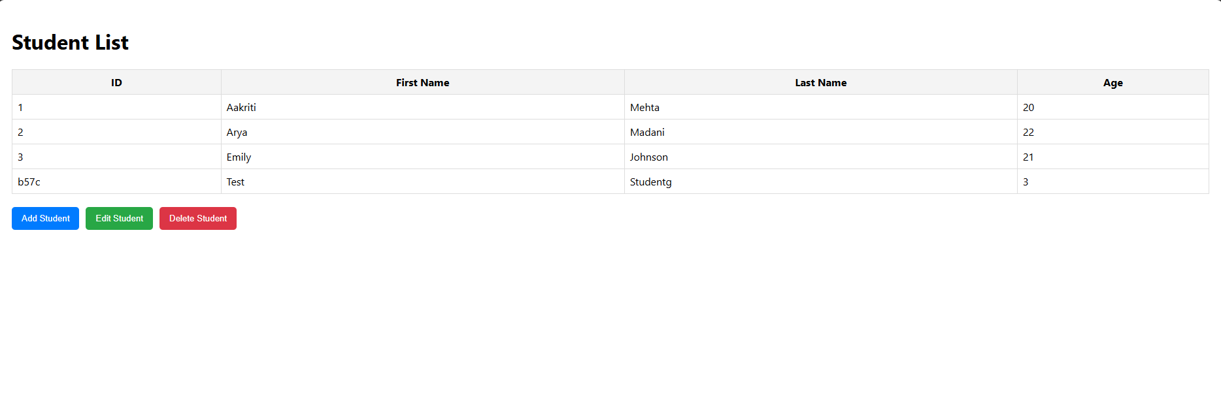  
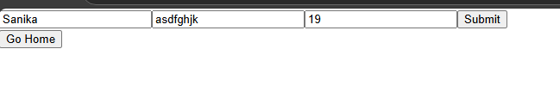  
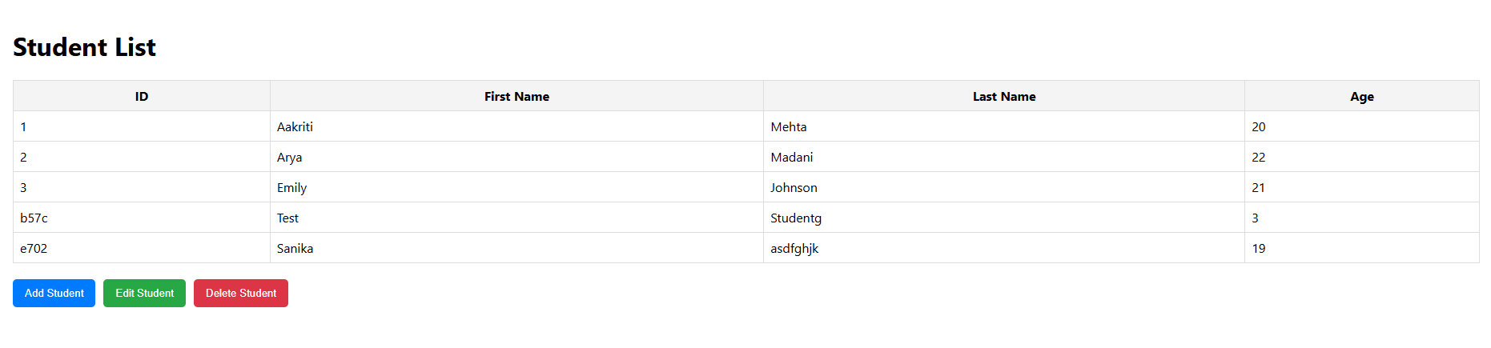**

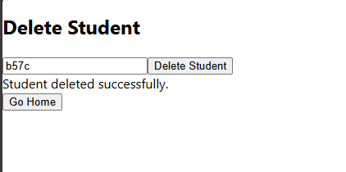  
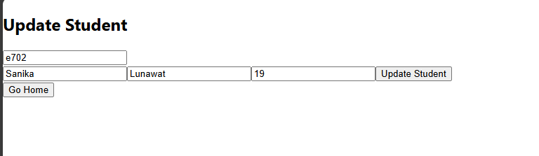  
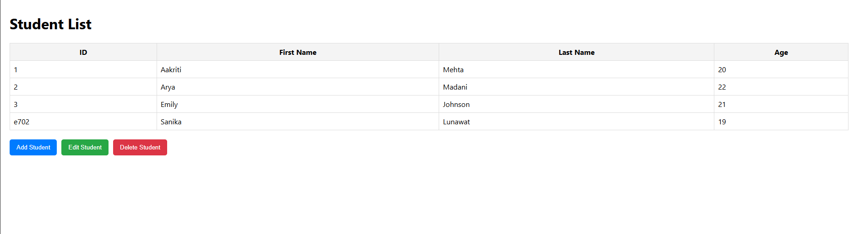

**Steps for execution:**

1. Create a React Application

2. Set up a Mock API Server (using json-server)

3. Create the StudentList Component

4. Implement Navigation

**Conclusion:**

We have learned about axios and routing.

**Postlab questions:**

1) Different ways to Add Api in React/Javascript with example.

· **Fetch API**: Native, simple to use, and built into modern browsers.

· **Axios**: Popular library with additional features like interceptors and automatic data transformation.

· **jQuery AJAX**: Older method, useful if jQuery is already in use.

· **XMLHttpRequest**: Legacy method, more verbose but still supported.

· **GraphQL**: Query language for APIs, often used with libraries like Apollo Client for more efficient data fetching.